## This is meant to be super simple and can just be “done” in spare time.

## You will make typos. This will lead to debugging. Which is how we learn,

This will teach how some github commands work. You can ignore anything after #### marks which are meant to be comments.

## Step 1: github clone, etc

This is super simple, clean and easy

#have github installed (Examples will be based on linux, I don’t know how windows version differs, I expect, not much.

git clone <https://github.com/CiscoDevNet/netprog_basics> ### this will clone the remote repository to your machine. You now have a local copy

ls # see the new directory

cd netprog_basics ## get into the directory

git status

ls -la ###### note all the stuff. Cool. There is also a hidden directory (hence the “a” in the command) that is for git. We leave that alone

## Step 2: change it, update it,

touch myfile1 ######## this creates a file

git status ########## it shows the file is there, and that is interesting, but it isn’t being tracked by git

git add myfile1 ##### this adds our new file to the staging area. Its now being tracked

touch myfile2

git status

git add myfile2

git status

git commit -m “my first commit” ########### this will commit the files. Note you HAVE to add the -m or it will make you edit it in a vim window, which some people may not like.

This will probably throw an error if you haven’t commited before. Just follow the instructions, and it does NOT matter what your user or email is since this is on your local machines git.



git commit -m “my first commit”

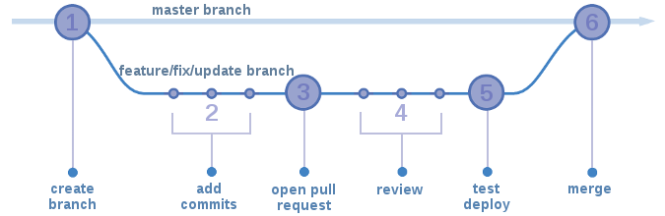

## Step 2: create a branch, do stuff

##### developers will take a good code base, make a branch, and do work on the branch. Then they make sure it works before merging it into the main code base.

git branch mybranch ### this creates the branch

git status ###### note you are still on the master branch

git checkout mybranch

git status ### now on the mybranch

git checkout master

git status ### now on the master branch

git checkout mybranch

touch branchfile

git add branchfile ### add it to the branch,

git status

git commit -m mybranchcommit

git checkout master

git merge mybranch ### this merges the changes on the branch, back to the master repository